

**INDUSTRIAL TRAINING REPORT**

**ITD27112**

**SEMESTER II 2020/2021**

**CREATED BY :**

**MUHAMMAD HAZIQ BIN JUSOH**

**DIPLOMA INFORMATION AND TECHNOLOGY**

**FACULTY OF INFORMATICS & COMPUTING**

**UNIVERSITY SULTAN ZAINAL ABIDIN**

**INDUSTRIAL TRAINING REPORT**

**(ITD27112)**

**14 MARCH 2021 TO 27 AUGUST 2021**

**MAJLIS SUKAN NEGERI TERENGGANU, JALAN LAPANGAN TERBANG, GONG BADAK 21300 KUALA TEREGGANU, TERENGGANU**

**CONFIRMATION ACADEMIC SUPERVISOR**

This Final Report of Industrial Training was sent to the Faculty of Informatics & Computing, Sultan Zainal Abdin University, Besut Campus and was accepted as fulfilling the requirements for the Diploma in Information Technology.

PUAN FATIMAH BINTI GHAZALI

Academic Supervisor

Faculty of Informatics & Computing,

Sultan Zainal Abidin University,

Besut Campus.

Date :

iii

**CONFIRMATION INDUSTRIAL SUPERVISOR**

I have confirmed that I have received and read this report and in my opinion this report is sufficient in terms of scope and quality to qualify for self-approval at the level of Diploma of Information Technology

ENCIK SAARI

Industrial Supervisor

Majlis Sukan Negeri Terengganu,

Jalan Lapangan Terbang,

Gong Badak 210800 Kuala Terengganu,

Terengganu

Date :

iv

**DECLARATION**

With this, I state emphatically that this report was completed entirely by Muhammad Haziq Bin Jusoh. This report is never sent to a university, college, or other organization for an academic, qualification, certificate, diploma, or degree. I hereby warrant that the work I submit does not infringe any existing copyright.

Name: MUHAMMAD HAZIQ BIN JUSOH

Matric Number: DTA

Date :

v

**ACKNOWLEDGEMENT**

Thank God for His blessings until I managed to complete my industrial training for 6 months, which is 24 weeks from 14 March to 27 August 2021, Jabatan Hal Ehwal Agama Terengganu. Because of that, I am also grateful for the opportunity to meet many great people and professionals who led me throughout the study period to complete my diploma for 2 years. I would like to take this opportunity to thank the Jabatan Hal Ehwal Agama Terengganu and all the staff especially YBRS. Tuan Haji Mat Azmi Bin Arshad, Head of the Jabatan Hal Ehwal Agama Terengganu, and Puan Jasniza Binti Mohd Jaafar as my Industrial Supervisor for giving me the opportunity to undergo Industrial Training as I was busy with my job, taking the time to listen, drive, and keep me on the road the right one. Jabatan Hal Ehwal Agama Terengganu has given me the opportunity to study as much as possible and it will definitely give me experience for a career in the future.

In addition, I would like to thank my Academic Supervisor, Mrs. Fatimah Binti Ghazali for guiding me to complete my Industrial Training, and to my family who have always given support and encouragement as well as infinite love.

In conclusion, I would like to thank all the classmates with me for supporting and helping me overthe years, all the experiences I have I will use to the best of my ability.

vi

**ABSTRACT**

Industrial training is an important phase for students of Universiti Sultan Zainal Abidin (UNISZA) as a condition to complete their studies at the Diploma Session 19/20 level. This is because, well -planned, well -executed and evaluated industrial training is very helpful in developing a professional attitude for students before stepping into the real world of work. In this way, it is possible to develop awareness of the industry’s approach to problem solving, based on a broad understanding of the processes and ways the organization operates. The purpose and motivation of this industry training is to be able to receive discipline, skills, teamwork and technical knowledge through the right training environment and be able to help me as a student in the field of Information Technology in an effort to increase the level of confidence and self -discipline. For 6 months, 24 weeks from 14 March to 27 August 2021, I underwent training at the Jabatan Hal Ehwal Agama Terengganu and placed in the ICT Unit under the administration of Management Services, I was assigned to make system improvements to be more efficient to help organizations facilitate daily work in using the system. During this industry training, I learned a lot related to information and technical technology as well as internet networking.

vii

**TABLE OF CONTENT**

|  |  |
| --- | --- |
|  | **PAGE** |
| **CONFIRMATION** | iii ­- iv |
| **DECLARATION** | v |
| **ACKNOWLEDGEMENT** | vi |
| **ABSTRACT** | vii |
| **TABLE OF CONTENT & REFERENCES** | viii - ix |
| **LIST OF TABLES** | x |
| **LIST OF FIGURES** | xi |

|  |  |  |
| --- | --- | --- |
| **CHAPTER 1** | **INTRODUCTION** |  |
| 1.1 | Introduction To The Organization | 1 |
| 1.2 | Industrial Training Job Scope | 2 |
| 1.3 | Objectives Industrial Training | 3 |
| 1.4 | Report Structure | 3 |
| **CHAPTER 2** | **PROJECTS & ASSIGNMENTS** |  |
| 2.1 | **E-Dakwah** |  |
|  | 2.1.1 Introduction |  |
|  | 2.1.2 Methodology & Design |  |
|  | * + 1. Implementation     2. Result |  |
|  | 2.1.5 Impact & Benefit to the Company |  |

viii

|  |  |
| --- | --- |
| **CHAPTER 3**  **CHAPTER 4** | **DAILY TASK / ASSIGNMENT**  **CONCLUSION** |
| 4.1 | New Knowledge / Skill Gained During the Training |
| 4.2 | Limitations |
| 4.3 | Constraints and Suggestions |
| 4.4 | Challenges and Opportunities |
| 4.5 | Summary |
| **REFERENCES** |  |

ix

**LIST OF TABLES**

|  |  |  |
| --- | --- | --- |
| **FIGURE** | **TITLE** | **PAGE** |
| 1.1 | First table in chapter 1 | 10 |
| 1.2 | Second table in chapter 1 | 15 |
| 2.1 | First table in chapter 2 | 20 |
| 2.2 | Second table in chapter 2 | 22 |

x

**LIST OF FIGURES**

|  |  |  |
| --- | --- | --- |
| **FIGURE** | **TITLE** | **PAGE** |
| 1.1 | First figure in chapter 1 | 10 |
| 1.2 | Second figure in chapter 1 | 15 |
| 2.1 | First figure in chapter 2 | 20 |
| 2.2 | Second figure in chapter 2 | 22 |

xi

**CHAPTER 1**

**INTRODUCTION**

* 1. **INTRODUCTION TO THE ORGANIZATION**

The Jabatan Hal Ehwal Agama Terengganu (JHEAT) is a department that responsible in particular in matters relating to management and state religious administration. Jabatan Hal Ehwal Agama Terengganu as well as government departments others in Malaysia, have their own mission, objectives and vision in its establishment. JHEAT’s main mission is to realize the state government’s vision towards making Islam an ad-Din. To give birth to a strong Muslim family to the teachings of Islam and has a high competitiveness. While the objective to give birth to a society that makes Islam a way of life (ad-Din) encompassing the whole of life encompasses faith, morals, economics, social, education and culture.

Uphold justice according to Islamic laws as well as control and eradicate apostasy, heresy, immorality, superstition and others that affect chastity Islam. In addition, JHEAT is also a policy implementing body that has a field authority over Islamic religious affairs determined by MAIDAM as a party state religious authority and the Terengganu State Government. The department consists of eight main divisions, namely the Administration Division and Finance, Dakwah Division, Education Division, Mosque Management Division, Prosecution Division, Enforcement Division, Research Division and Division Islamic Family Law. Each such part has its own role.

1

* 1. **INDUSTRIAL TRAINING JOB SCOPE**

I was placed in the Information Technology (ICT) division under Administration, which is Management Services at the Jabatan Hal Ehwal Agama Terengganu. I learned a lot about high -tech living in a real career. At the Jabatan Hal Ehwal Agama Terengganu, the Information Technology (ICT) division here manages many Religious Affairs systems in the State of Terengganu, manages technical problems at the Jabatan Hal Ehwal Terengganu and manages internet network problems if the staff here have such problems and also multimedia works. Therefore, regarding this job, I was given the task of improving the system, namely SMAONLINE, which has long been abandoned with the aim of facilitating students who wish to apply for admission to religious schools.

In addition, I also carry out duties in assisting with technical work such as internal and external computer repairs in the event of a malfunction complaint. Apart from that, I also do internet network security work at the Jabatan Hal Ehwal Agama Terengganu if there are complaints of damage. Besides, I was given tasks in creating design works such as making posters and designing posters. Finally, I was also assigned to enter the ICT equipment data into excel.

2

**1.3 OBJECTIVES INDUSTRIAL TRAINING**

The objectives of this industrial training are:

1. To gain experiences working in field related
2. To exposed student with working environment
3. To provides student a training and experiential learning opportunities for the development skills.
4. To provide a qualified certificate

**1.4 REPORT STRUCTURE**

Chapter 1 will provide an overview of the introduction of the industry training report, organizational details and workspace. Chapter 2 focuses on projects that have been assigned to trainees during industrial training. Next For this chapter 3, more on our daily tasks and activities during industrial training. Finally, chapter 4 is the conclusion to all chapters and challenges or opportunities during industrial training.

3

**CHAPTER 2**

**PROJEK / ASSIGNMENT**

**CHAPTER 3**

**DAILY TASK**

Among the task I have done during my industrial training are :

**3.1 SYSTEM**

**-** Change the background for SmaOnline   
 - Change the colour background for SmaOnline

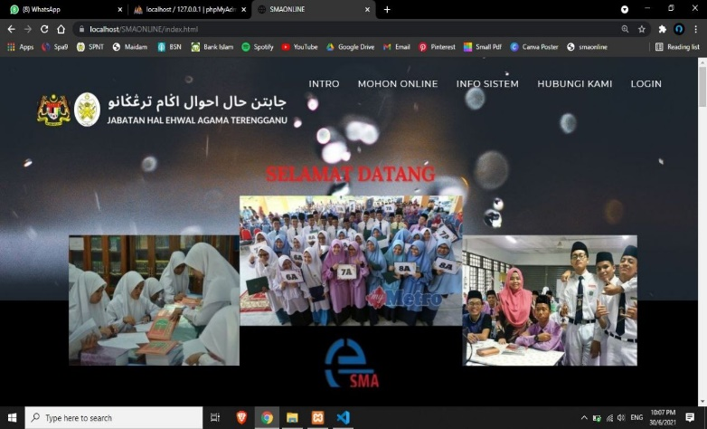

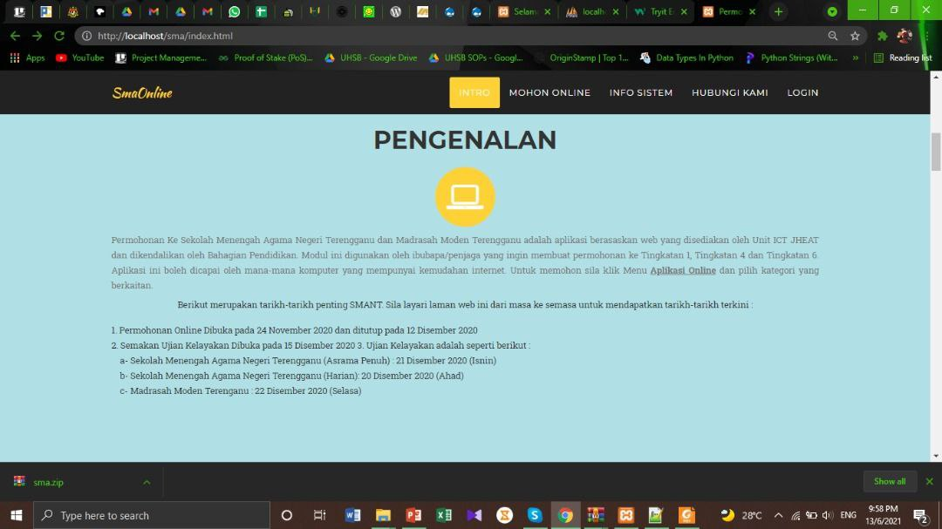

Figure 1 : Create A New Background Design Page Home And Change The Colour Background At Page Intro SmaOnline

**3.2 TECHNICAL**

- Learn how to format computer   
 - Learn how to cleaning window printer   
 - Assemble items and repair computers   
 - Handle install a laptop for use of each meeting in the main meeting room

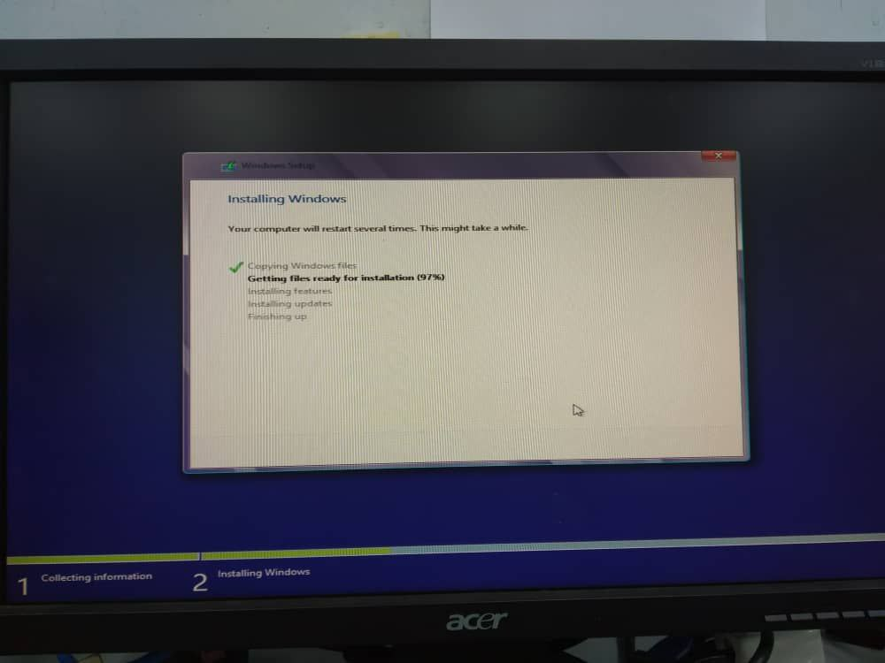 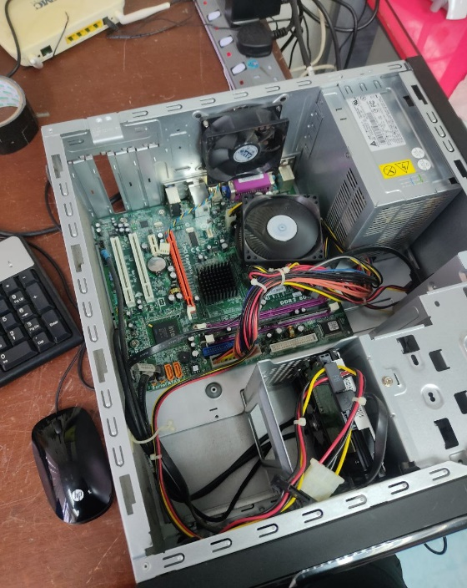

Figure 2 : Format Computer And Replacing A Faulty Power Supply

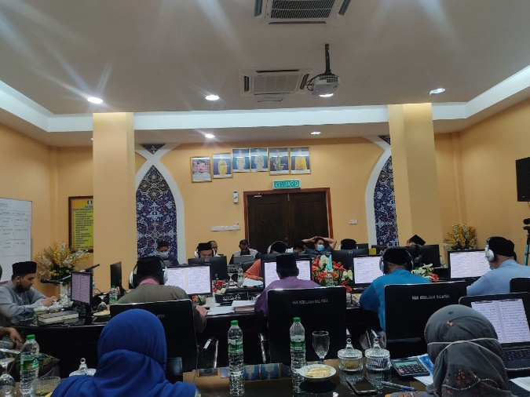 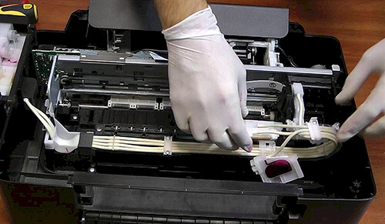

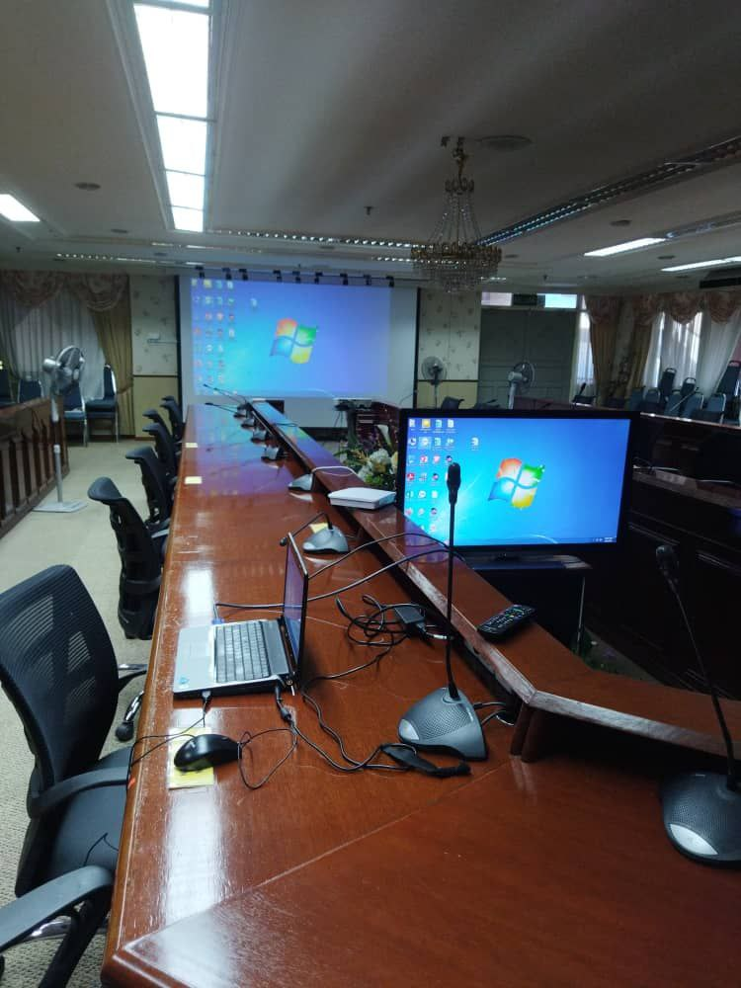

Figure 3 : Handle Program As Technicion, Install A Laptop For Meetings And Printer Cleaning

**3.3 NETWORKS**

- Learn how to setup Ip Address at computer   
 - Learn how to install switches on shelves  
 - Make a configure proxy access to the internet  
 - Manage the internet section if it crashes

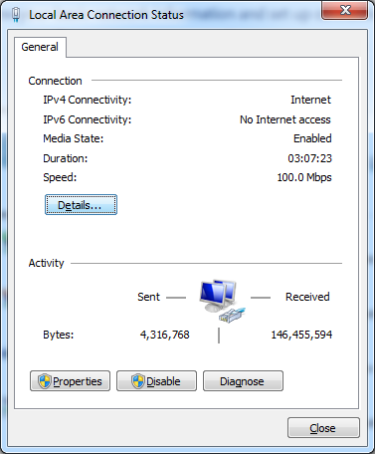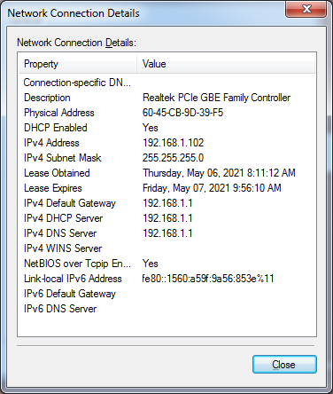

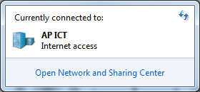

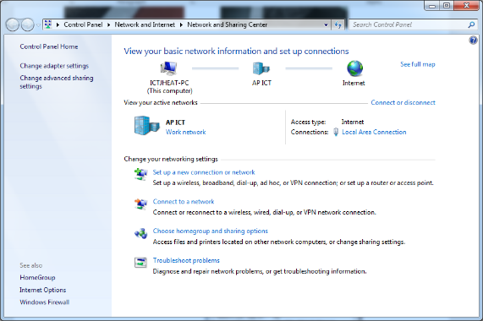

Figure 4 : Setup The IP Address At Komputer

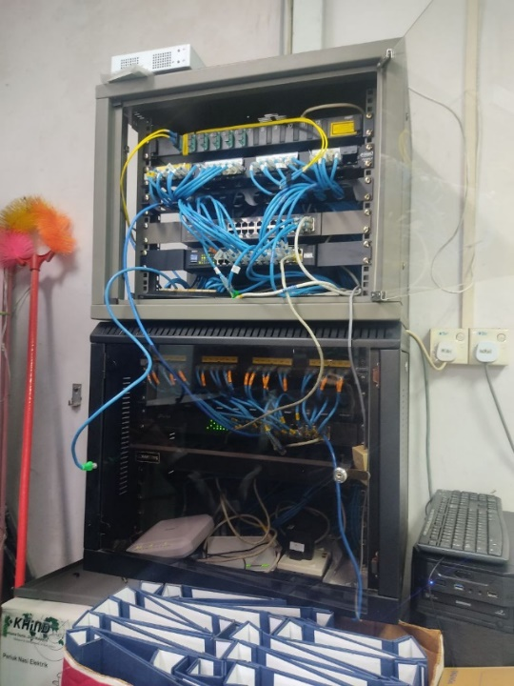 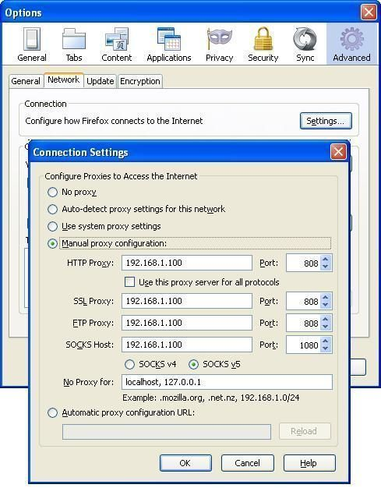

Figure 5 : Switch Installation On Server Rack And Configure Proxy Access to the Internet

**3.4 DESIGN**

- I was assigned too modify the poster   
 - I was assigned to make a poster

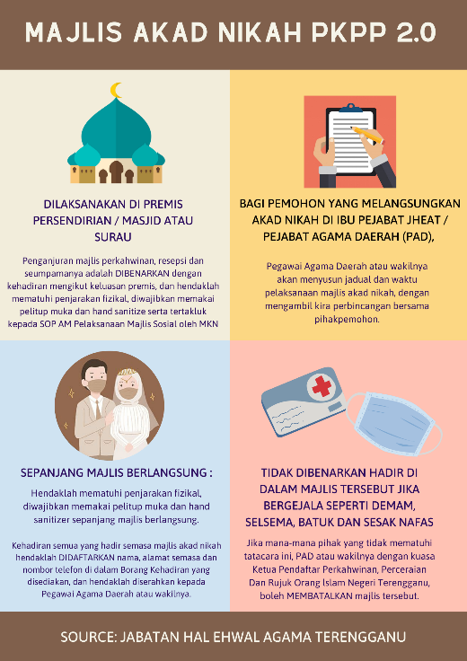 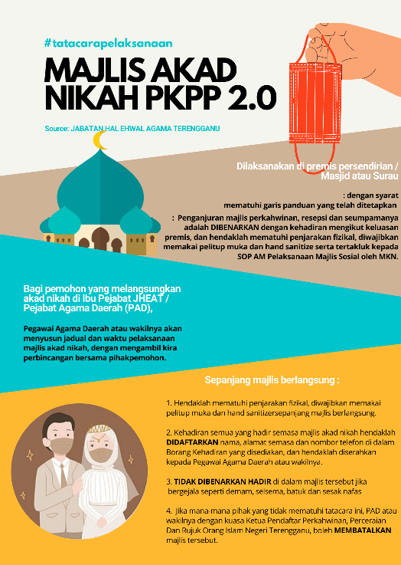

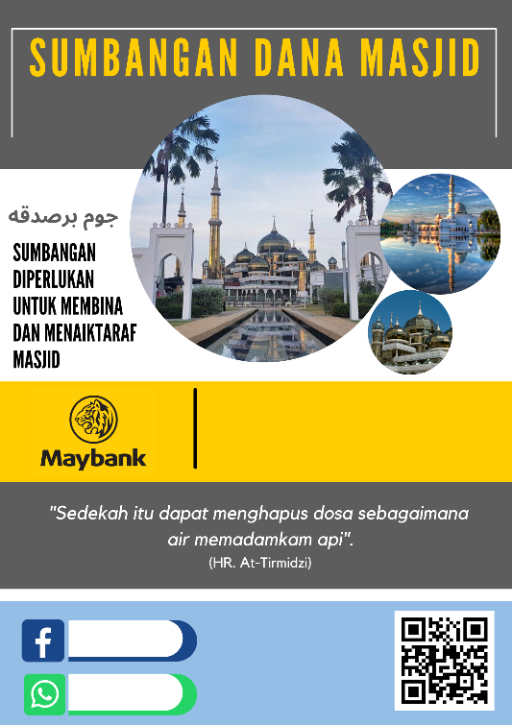 

Figure 6 : Edit The Poster

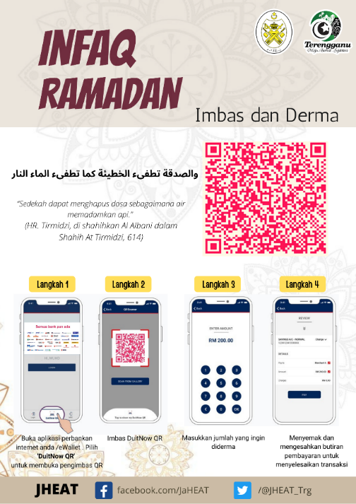 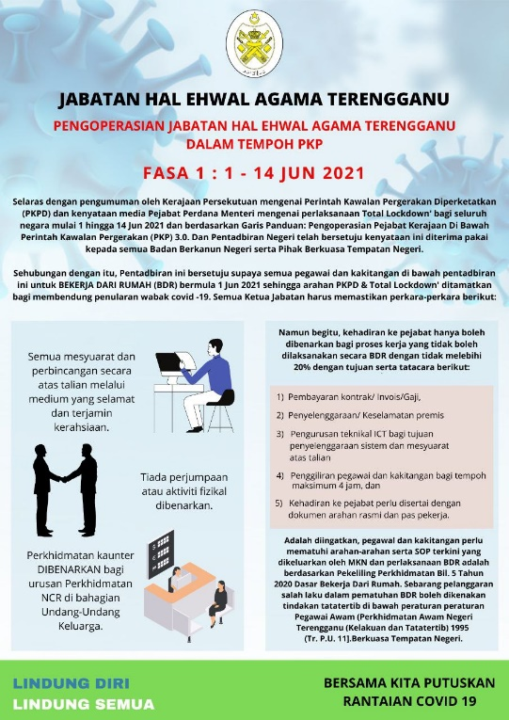

Figure 7 : Create A Poster

**3.5 KEY IN DATA**

- I was assigned to manage, update and enter data related to ICT

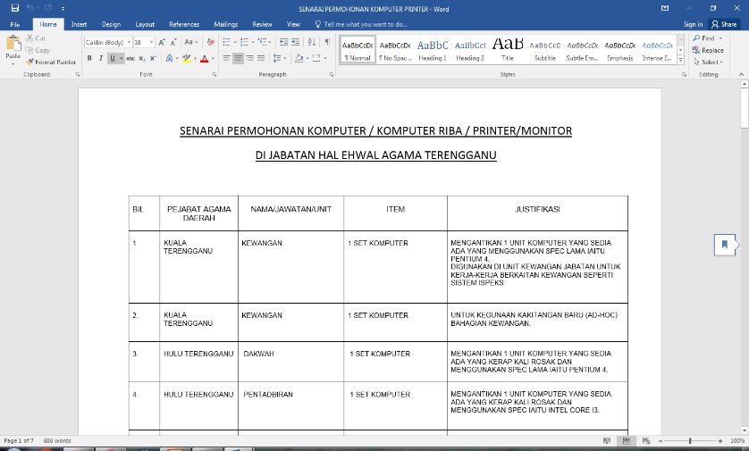

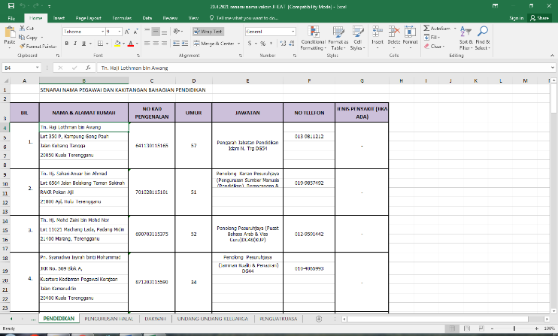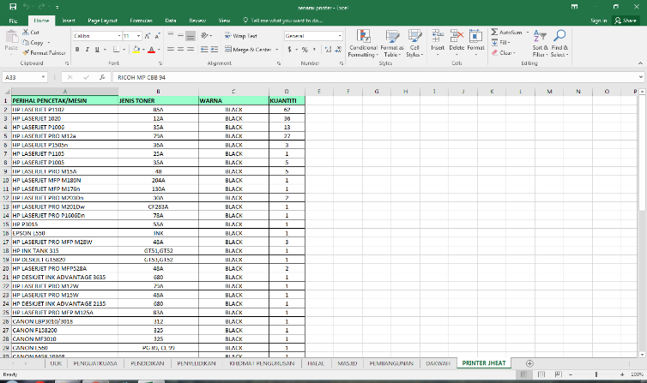

Figure 8 : Manage, Update And Enter The Data Printer And Komputer

**CHAPTER 4**

**CONCLUSION**

**4.1 NEW KNOWLEDGE / SKILL GAINED DURING THE TRAINING**

During the training, I gained a lot of new knowledge and skills because I had to learn how to do a job or deal and communicate with the staff at the Jabatan Hal Ehwal Agama Terengganu when they had problems in ICT.

In conclusion, I learned a lot about the world of information technology today. I can also learn how to use the system properly, learn how to operate internet, technical, design networks and enter ICT equipment data or manage ICT related data

**4.2 LIMITATIONS**

During these 24 weeks of industrial training, I faced some limitations. The first was the absence of a special computer for industrial training students which forced me to use my own laptop. So, it would be inconvenient when someone uses a computer, so sometimes I have to use my own laptop. The second limitation is, as a trainee, I have not learned more about how to make support and technical when the staff here have some technical problems and internet problems, as most of it is done by the staff here and during this Lockdown also I could not learn many things because I only come to the office once a week. Lastly, as a trainee you must have limitations to do some of the tasks because some of the tasks are government affairs.

**4.3 CONSTRAINT AND SUGGESTION**

**Constraint**

* Small rooms and a large number of staff
* Less of computer

**Suggestion**

* In the future, it may be possible to add laptops for trainees and place them in larger spaces and smaller numbers again in the covid-19 season

**4.4 CHALLENGES AND OPPORTUNITIES**

**Challenges**

- I have to learn new things I have never done and find out about the assignment.

- I have to learn fast because I only underwent industrial training for 24 weeks only.

- I must always remember the steps of making system improvements and all other tasks   
 correctly and safely so that I do not make mistakes.

- There is a task that I have to do is difficult but I keep trying by asking the task a handful   
 of staff here who have extensive experience in the field of Information Technology so that   
 I can submit the task on time.

**Opportunities**

Industrial training took me into the most challenging world of this century with all -new technologies and added to my newfound knowledge in the IT industry. I had the opportunity to understand what career life really is so that I could apply it when I was already in career life. During my 24 weeks of industrial training, I have learned many new things in IT technology, as I was placed in the ICT Unit here by learning other than the systems taught to make improvements and related things in this field of IT.

In addition, I also learned how to do work quickly so that I could submit work on time by the supervisor. From a different perspective, it is much better when I have to always focus because I have made quite a big mistake of some parties because the task involves departmental affairs.

**4.5 SUMMARY**

All these chapters will cover my entire experience while undergoing industrial training as mentioned in previous chapters, this industrial training is very important for final year students to gain experience, and a lot of new knowledge because after graduation, we have to find a job.

Therefore, it will also improve good communication and social skills with high -ranking people and experienced in the industry, this will make us more responsible to do good work, great team members and more confident to deal with people and situations. which is physically and mentally challenging.

In conclusion, I can attest that every student has different experiences and tasks because it is based on different industrial training places. Some may be doing IT -related jobs or may be other jobs in industrial jobs. All of this makes us more confident to apply our vast current experience and knowledge in the career field.

**REFERENCE**

1) <http://smaonline.terengganu.gov.my/>

2) <https://semakan.jais.gov.my/>

3) Puan Jasniza Binti Mohd Jaafar (Industrial Supervisor)

4) Industrial Training Report by Dini Izzati